1.На **cart-page** разместить **bootstrap-button** для **ajax-remove одного** товара:

resources\views\**shop\cart-standard.blade.php**

<button class="btn btn-danger **listbuttonremove**" **id="{{$cart->id}}"**><i class="fa fa-trash-o" aria-hidden="true"></i></button>

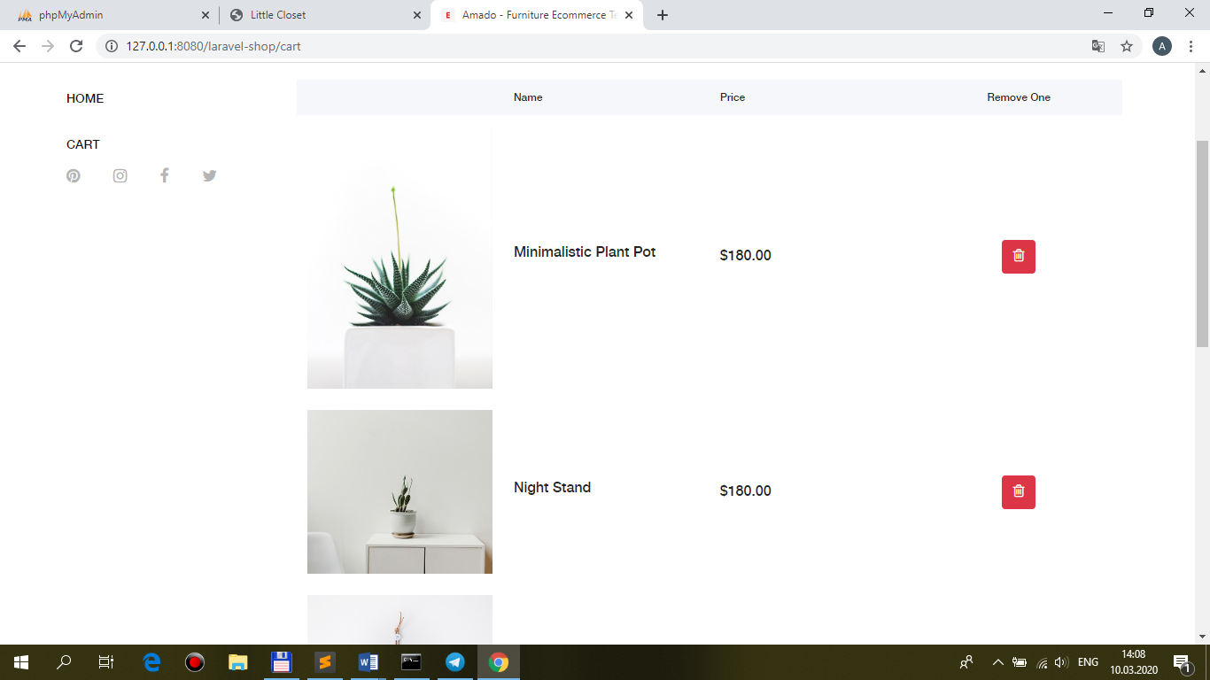

+навесить событие вызова метода удаления:

resources\views\**shop\cart.blade.php**

@section('js')

**<script src="{{ asset('public/js/main.js') }}"></script>**

<script>

$(document).ready(function(){

$('.btn.btn-danger.w-100').click(function(){

form_clearall.submit();

});

**$('.listbuttonremove').click(function(){**

**BaseRecord.clearone($(this).attr('id'));**

**return false;**

**});**

});

</script>

@endsection

2.Реализовать **ajax-удаление одного** товара:

recources\views\**shop\layout.blade.php**

**<!-- CSRF Token -->**

**<meta name="csrf-token" content="{{ csrf_token() }}">**

**public\js\main.js**

**$.ajaxSetup({**

**headers: {**

**'X-CSRF-TOKEN': $('meta[name="csrf-token"]').attr('content')**

**}**

**})**

**clearone: function(id)**{

var ajaxSetting={

**method: 'post',**

**url: './clearone',**

**data: {**

**id: id,**

**},**

success: function(data){

alert(data);

},

};

$.ajax(ajaxSetting);

},

**routes\web.php**

Route::**name('clearone')->post('/clearone', 'ShopController@clearone')**;

**app\Http\Controllers\ShopController.php**

/**

* Destroy one from cart.

*

* @return \Illuminate\Contracts\Support\Renderable

*/

public function **clearone(Request $request, Cart $cart)**

**{**

**$cart->find($request->id)->delete();**

}

В результате – при **click** на кнопку удаления и **ручном(пока) обновлении** страницы – **удаление** товара:

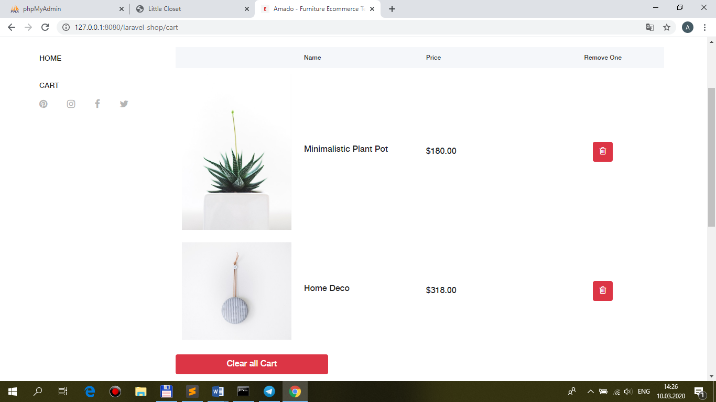

3.**Ajax-обновление** страницы **после удаления** товара:

**public\js\main.js**

clearone: function(id){

var ajaxSetting={

method: 'post',

url: './clearone',

data: {

id: id,

},

success: function(data){

//alert(data);

**BaseRecord.cart();**

},

};

$.ajax(ajaxSetting);

},

**cart**: function(){

var ajaxSetting={

**method: 'get',**

**url: './cart',**

success: function(data){

**$('#pannel').html(data.table);**

**$('.listbuttonremove').click(function(){**

**BaseRecord.clearone($(this).attr('id'));**

**return false;**

**});**

},

};

$.ajax(ajaxSetting);

},

resources\views\**shop\cart.blade.php**

**<tbody id="pannel">**

**@include('shop.cart-standard')**

</tbody>

**app\Http\Controllers\ShopController.php**

public function **cart**(**Request $request,** ShopRepository $repository)

{

$carts = $repository->fromCart();

**// Ajax response**

**if ($request->ajax()) {**

**return response()->json([**

**'table' => view("shop.cart-standard", ['carts' => $carts])->render(),**

**]);**

**}**

return view('shop.cart', compact('carts'));

}

